CROSS BORDER DIALOG WORKING GROUP MEETING

Date: 17.05.2024
Location: Energy Community Secretariat, Vienna

- SUMMARY NOTES
The Deputy Director and Legal Counsel of the Energy Community Secretariat, Mr. Buschle, warmly welcomed the members of the working group and expressed his appreciation for their participation in this cross-border dialogue and for entrusting the Secretariat to facilitate the discussion.
Both delegations expressed appreciation for the joint efforts and the successes achieved within the framework of the Cross Border Dialog Working Group (Working Group). The Working Group verified the "Report on the Results of Geodetic Surveys" and the "Report on the Results of Hydrological Measurements," concluding that no further obligations are anticipated.
Bosnia and Herzegovina delegation confirmed that as agreed no ongoing preparatory works are occurring at the project location and that no construction permit application has been submitted by the project developer. However, the project remains of interest to the developer.
Both delegations provided updates regarding Decision IX/4c–V/4c of the Meeting of the Parties to the Convention on Environmental Impact Assessment in a Transboundary Context and Decision 45 COM 7B.93 (N 100bis) of the UNESCO World Heritage Committee. They informed that currently there is no joint action plan for implementing these decisions. Both delegations expressed interest in following and implementing the requirements of the decisions and potentially using this roadmap to guide other international communities.
The delegation of Bosnia and Herzegovina informed that they are ready to conduct an Environmental Impact Assessment (EIA) of the HPP Buk Bijela project with transboundary consultations, including Montenegro in all initial steps of the procedure. Furthermore, they have informed that the project sponsor has confirmed securing the necessary funding for preparing the assessment and that the assessment will be expanded to include the Piva HPP, built in 1976, to evaluate the cumulative impacts of both the existing and planned hydropower projects as well as other filed assessments that should improve the description of the aspects of the current state of environment (baseline scenario).
The Secretariat referred to the complaint registered under the Energy Community dispute settlement rules, case ECS-25/21, highlighting the interconnection between the HPP Buk Bijela and HPP Foča, as well as other linked hydropower projects. The developer confirmed these interconnections, noting that HPP Foča's viability depends on HPP Buk Bijela. Consequently, this alternative must be thoroughly evaluated in the EIA from both an alternative and cumulative perspective. The Secretariat advised the delegation to consult relevant guidelines, including: the "Interpretation suggested by the Commission regarding the application of the EIA Directive to ancillary/associated works" (2012), which encompasses the "centre of gravity test" and the "EIA Guidance - EIA Report" (2017), which includes a template with guiding questions for describing the project and its alternatives. The Secretariat will supply guidance materials for conducting a gravity test to define the scope and objectives of the assessment and provide other relevant guidelines to support the overall process.
The Working Group discussed additional preparatory information that needs to be gathered. In this context, the Bosnia and Herzegovina delegation requested Montenegro to provide the project developer with a detailed assessment of the current cross-section profiles of the Piva River flow, essential for calculating the flow regime. The delegation further noted that creating a hydrodynamic model is a crucial activity for preparing the EIA Report. This model will encompass the HE Piva-Šćepan Polje domain on the Piva River, the upstream section of the Tara River from Šćepan Polje, and the Drina River from Šćepan Polje to the Buk Bijela dam. To define the complete domain geometry, the geometry of the flow section from HE Piva-Šćepan Polje on the Piva River is required. The delegation of Montenegro requested that the concrete assignment be provided to their Ministry through the focal point of the Working Group. This would enable them to contact the relevant authorities in Montenegro to gather the necessary information.
The Bosnia and Herzegovina delegation requested information from the Montenegro delegation regarding the UNESCO site "Durmitor" National Park, "Piva" Nature Park, and other relevant environmental data. This includes a list of species and other natural values to provide necessary information on the current state of the environment.
The Bosnia and Herzegovina delegation informed that they are awaiting the project developer's notification letter concerning the project, which will trigger revision of the environmental permit and a new EIA procedure. Once submitted, competent authority, the Ministry of Ecology, Spatial Planning and Urbanism of Republika Srpska will compile the documents and submit them for consultation, including transboundary consultations with the authorities concerned in Montenegro. The Ministry of Ecology, Spatial Planning and Urbanism of Republika Srpska will then decide on the on the scope of the project’s EIA report.
Both delegations express their willingness to utilise the Working Group as a facilitator of transboundary communication, in addition to employing hard copy communication via postal channels. Furthermore, the Working Group concluded that it would be beneficial to jointly work on scoping the EIA report. Specific steps were agreed upon to facilitate communication regarding cross-border information and the transmission of information to Montenegro within specific deadlines. This step-by-step communication process is incorporated into the new roadmap.
Given the necessity to consult numerous institutions during the preparation, both delegations will compile a list of institutions and contact points to ensure smooth and efficient communication and consultation. This will facilitate the consultation process with relevant authorities, including local municipalities. Additionally, both delegations will maintain a list of concerned public entities, including civil society organizations focused on environmental protection and tourism activities. These lists will be periodically updated. The Secretariat emphasized the importance of integrating a specific communication plan into the scoping decision. This plan will provide the developer with a clear overview of both national and transboundary obligations for public consultation.
Both parties have committed to collaborating on compiling and preparing the assessment of potential impacts. The Bosnia and Herzegovina delegation has informed that the developer have contracted an expert team to compile the EIA report within 18 months, with the first draft expected to be ready in the last quarter of 2025.
The work of the Working Group will proceed with electronic communication to define the scoping decision. The Secretariat will facilitate any necessary communication between the two delegations as needed up until a decision on the scope of the EIA is reached.

- AGENDA

- Welcome
- Taking stock of the steps taken and update on members
- State of relevant processes/procedures concerning the focus project
  - Presentation by both delegation and the Secretariat
- Discussion on update points to the roadmap and timeline
- Identification of key stakeholders and transboundary engagement strategies
- Next steps and AOB.

- ROADMAP (phase II) EIA HPP Buk Bijela

Step 1: Preparatory phase and exchange of information
Task 1.1. The Ministry of Energy of Republika Srpska to provide a detailed assignment regarding the complete domain geometry. Specifically, the geometry of the flow section from HE Piva-Šćepan Polje on the Piva River is required. This information is necessary for the model, which will encompass the HE Piva-Šćepan Polje domain on the Piva River, the upstream section of the Tara River from Šćepan Polje, and the Drina River from Šćepan Polje to the Buk Bijela dam.
The Ministry of Tourism, Ecology, Sustainable Development and Northern Region Development of Montenegro to provide the current cross-sectional profiles of the flow of the Piva River to the project developer after internal exchange with competent authorities.

Focal point:
BIH: Milan Bastinac, Ministry of Energy of Republika Srpska
MNE: Brankica Cmiljanović, Ministry of Tourism, Ecology, Sustainable Development and Northern Region Development

Deadlines:
BIH: Detailed assignment due 24 May 2024.
MNE: Information/feedback due 07 July 2024.

Task 1.2. The Ministry of Tourism, Ecology, Sustainable Development, and Northern Region Development of Montenegro are tasked with providing electronically available information pertinent to describing the current state of the environment (baseline scenario) to the Ministry of Spatial Planning, Construction, and Ecology of Republika Srpska. This includes but is not limited to information on the National Park "Durmitor," Nature Park "Piva," and other relevant environmental data for the area. Any subsequent updates or revisions will be promptly communicated to the Ministry of Spatial Planning, Construction, and Ecology of Republika Srpska.
Focal point:
MNE: Brankica Cmiljanović, Ministry of Tourism, Ecology, Sustainable Development and Northern Region Development
BIH: Ljiljana Stanisljevic Ministry of Spatial Planning, Construction and Ecology of Republika Srpska
Deadlines:
MNE: Initial information due by 12 July 2024.
MNE: Subsequent updates or revisions within 15 days of receiving new information.
BIH: Confirm receipt within 5 days of receiving the information.

Task 1.3: The Ministry of Tourism, Ecology, Sustainable Development, and Northern Region Development of Montenegro and the Ministry of Spatial Planning, Construction, and Ecology of Republika Srpska to compile a list of authorities concerned to be consulted during the scoping phase.
Focal point:
MNE: Brankica Cmiljanović, Ministry of Tourism, Ecology, Sustainable Development and Northern Region Development
BIH: Ljiljana Stanisljevic Ministry of Spatial Planning, Construction and Ecology of Republika Srpska
Deadlines:
MNE: Compile the list due by 28 June 2024.
BIH: Compile the list due by 28 June 2024.

Task 1.4: The Secretariat to provide guiding materials to the Ministry of Tourism, Ecology, Sustainable Development, and Northern Region Development of Montenegro and the Ministry of Spatial Planning, Construction, and Ecology of Republika Srpska for preparing the scoping and the EIA report. This encompasses guidance on describing the project and its alternatives, as well as instructions for conducting the gravity test for additional associated works related to the project. The Secretariat will continuously update new guidance and offer advice as needed or requested by the Ministries.
Focal point:
MNE: Brankica Cmiljanović, Ministry of Tourism, Ecology, Sustainable Development and Northern Region Development
BIH: Ljiljana Stanisljevic Ministry of Spatial Planning, Construction and Ecology of Republika Srpska
EnCS: Aleksandra Bujaroska, Legal Unit, Energy Community Secretariat
Deadlines:
EnCS: Provide guiding materials by 17 June 2024.
EnCS: Subsequent updates/request within 15 days of receiving update/request.

Step 2: Scoping of the new EIA for HPP Buk Bijela
Upon receipt of the project developer's notification for the Environmental Impact Assessment for Buk Bijela, the Ministry of Republika Srpska will compile the documents and submit them to Montenegro. Both delegations will engage in a minimum of 30 days consultations on the draft documents, including consultations with concerned public and authorities.
In executing the tasks, strict adherence to the rules of the EIA Directive, Espoo Convention, and relevant guidelines issued under these frameworks, as well as those provided by the Energy Community Secretariat, is imperative.
Task 2.1: The Ministry of Spatial Planning, Construction, and Ecology of Republika Srpska is assigned to provide the notification (application – “zahtjevu”) by the project developer, information on the nature of the decision which may be taken and the draft opinion on the scope and level of details of the information to be included by the developer in the EIA report for the HPP Buk Bijela to the designated focal point at the Ministry of Tourism, Ecology, Sustainable Development, and Northern Region Development of Montenegro, as well as the Energy Community Secretariat. The submission will include details on the nature of the permit (development consent) following the new EIA, an indication that the project is subject to EIA and transboundary consultation, and the contact information (contact point, email, telephone, and address) of the competent authorities where information can be obtained, and questions and comments submitted. Additionally, it will provide the scheduled timeline for document transmission, specify the possible nature of the decision, and outline arrangements for public consultations (including public hearings) and the communication plan for the transboundary consultation.
Focal point:
MNE: Brankica Cmiljanović, Ministry of Tourism, Ecology, Sustainable Development and Northern Region Development
BIH: Ljiljana Stanisljevic Ministry of Spatial Planning, Construction and Ecology of Republika Srpska
EnCS: Aleksandra Bujaroska, Legal Unit, Energy Community Secretariat
Deadlines:
BIH: Submit notification (application), information on the nature of the decision which may be taken and the draft opinion on the scope and level of details of the information to be included by the developer in the EIA report within 5 working days from receipt of the complete notification.

Task 2.2: The Ministry of Tourism, Ecology, Sustainable Development and Northern Region Development will confirm receipt and express interest in participating in the process. They will review the information on the decision, the description of the project’s possible transboundary impacts and the draft opinion on the scope and level of details for the EIA report, consult with the public and the authorities concerned, and provide comments and suggestions to the Ministry of Spatial Planning, Construction, and Ecology of Republika Srpska.
The Ministry of Spatial Planning, Construction, and Ecology of Republika Srpska will consider these comments and issue the final decision, on the notification and opinion on the scope and level of details of the information to be included in the EIA report. The Ministry of Spatial Planning, Construction, and Ecology of Republika Srpska will submit the decision to the Ministry of Tourism, Ecology, Sustainable Development and Northern Region Development. Both Ministries will publish the decision in accordance with their national rules.
The Secretariat will inform the complainants of case ECS- 25/21 about the new EIA procedure.
Focal point:
MNE: Brankica Cmiljanović, Ministry of Tourism, Ecology, Sustainable Development and Northern Region Development
BIH: Ljiljana Stanisljevic Ministry of Spatial Planning, Construction and Ecology of Republika Srpska
EnCS: Aleksandra Bujaroska, Legal Unit, Energy Community Secretariat
Deadlines:
MNE: Confirm receipt and express interest in participation within 5 working days from receipt.
MNE: Provide comments and suggestions within 40 days after the confirmation.
EnCS: submit information to the complainants (ECS 25/21) within 5 working days from receipt.
BIH: submit the decision (decision subjecting the project to EIA and scoping of the EIA) within 5 days of issuing

Both Ministries will strive to ensure that the total procedure does not exceed 60 days. They will also consider and account for any holidays or vacation periods that might pose obstacles to the effective and efficient participation of the public and concerned authorities.

Step 3: Draft new EIA for HPP Buk Bijela
The preparation of the EIA report (“studija”) will take place 18 month estimated as estimated by the developer. The Ministry of Spatial Planning, Construction and Ecology of Republika Srpska does not specify a deadline for the preparation and submission of the EIA report in its decision. Both Ministries will provide relevant information to the project developer and address any information requirements.
Once the draft EIA is prepared, the delegations will jointly organize public consultations, including transboundary consultations. For this purpose, stakeholder groups will be identified and engaged in direct exchange. For this purpose, a joint communication plan will be prepared in line with the best practices and international guidelines (Energy Community, European Commission, Espoo Convention, UNESCO, IUCN, etc.)
Both Ministries will directly inform and consult the stakeholders identified in the consultation list as authorities and public concerned. In carrying out this task, the Ministry of Spatial Planning, Construction and Ecology of Republika Srpska is obligated to meticulously consider the requirements for consultation, including the organization of hearings, involving both the public and relevant authorities. The preparation of the draft EIA report should be conducted in accordance with the national and international EIA rules and procedures, ensuring a transparent and participatory approach in the assessment process.
This process must respect the national EIA obligation and be compliant with the EIA Directive and the international Espoo Convention and UNESCO Convention.
The cross border working group will convey if needed to facilitate the process if needed.

Task 3.1: The Ministry of Spatial Planning, Construction and Ecology of Republika Srpska and the Ministry of Ecology, Spatial Planning and Urbanism of Montenegro to prepare joint communication plan. The plan should contain all practical details such as the venue for public hearings and publication methods. The plan should include specific additional communication methods for all identified authorities and concerned public. The plan will adhere to the best practices and international guidelines (Energy Community, European Commission, Espoo Convention, UNESCO, IUCN, etc.). If needed, the Energy Community Secretariat will provide guidance and clarification upon request from either delegation.
Deadlines:
BIH and MNE: jointly agree on a consultation plan within 30 days from initiating communication by the Ministry of Spatial Planning, Construction and Ecology of Republika Srpska.
EnCS: provide guidance ad clarification within 15 days from request.

Task 3.2: The Ministry of Spatial Planning, Construction and Ecology of Republika Srpska to submit draft EIA report and all relevant information and documentation to the Ministry of Ecology, Spatial Planning and Urbanism of Montenegro for consultations and review.
Focal points:
MNE: Brankica Cmiljanović, Ministry of Tourism, Ecology, Sustainable Development and Northern Region Development
BIH: Ljiljana Stanisljevic Ministry of Spatial Planning, Construction and Ecology of Republika Srpska

Deadlines:
BIH: to submit the draft EIA and relevant information within 5 working days of receiving the complete notification and agreeing on the consultation process.
MNE: Confirm receipt within 5 working days from receipt.

Task 3.3: Execute the joint communication plan and establish joint core review group to assess comments and opinions. This core group will prepare a joint consultation report.
Focal points:
MNE: Brankica Cmiljanović, Ministry of Tourism, Ecology, Sustainable Development and Northern Region Development
BIH: Ljiljana Stanisljevic Ministry of Spatial Planning, Construction and Ecology of Republika Srpska

Deadlines:
BIH and MNE: Both Ministries will execute the communication plan as agreed within the specified timeframes. Each Ministry will notify the other within 5 days in the event of any unforeseen delays in executing the plan.
EnCS: provide guidance ad clarification within 15 days from request.
BIH and MNE: prepare the joint consultation report within 30 days following the end of the consultation period.

Task 3.4: The Ministry of Spatial Planning, Construction, and Ecology of Republika Srpska will thoroughly consider the comments received during the consultation process in line with the best practices and international guidelines and inform the developer on the completeness of the EIA report, including any necessary supplements.
Focal points:
BIH: Ljiljana Stanisljevic Ministry of Spatial Planning, Construction and Ecology of Republika Srpska

Deadlines:
BIH: Within 40 days from the preparation of the consultation report.

Task 3.4a: The developer will supplement the EIA report. Depending on the completeness of the information gathered in tasks 3.2, 3.3, and 3.4, these tasks may need to be repeated.

Task 3.5: The Ministry of Spatial Planning, Construction, and Ecology of Republika Srpska to submit the draft EIA report (as supplemented by the developer after the consultations) along with the consultation report to the UNESCO World Heritage Centre and the Espoo Convention. A progress report on the preparation of the EIA and consultation process will be jointly prepared by both delegations. The Ministry of Spatial Planning, Construction, and Ecology of Republika Srpska will carefully consider any comments and suggestions from the UNESCO World Heritage Committee and the Espoo Implementation Committee, adhering to the deadlines set by these institutions. If needed the cross border working group will convey.

- BACKGROUND INFORMATION
Project concern
The 93 MW hydropower plant (“HPP”), with the reservoir volume of 15.7 million m3, on the Drina river within Bosnia and Herzegovina, with its reservoir stretching upstream to the Montenegrin border (Fig.1). The river Drina is formed by the confluence of the Montenegrin rivers Tara and Piva at the border with Bosnia and Herzegovina.
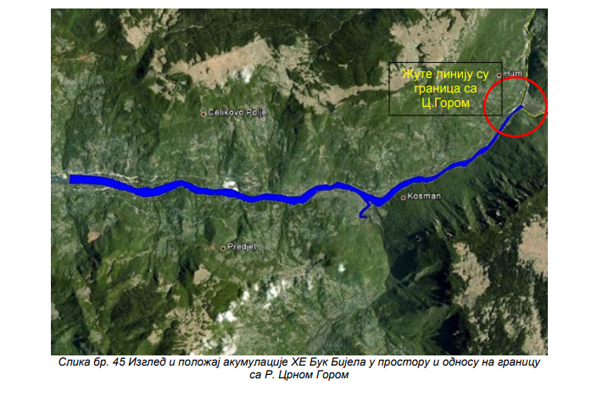
Fig 1. Location (EIA report HPP Buk Bijela, November 2012)
HPP Buk Bijela is a project subject to a mandatory environmental impact assessment (EIA) – Article 4(1) of, and point 15 of Annex I to the Directive 2011/92/EU (“EIA Directive”) “Dams and other installations designed for the holding back or permanent storage of water, where a new or additional amount of water held back or stored exceeds 10 milion cubic metres”.
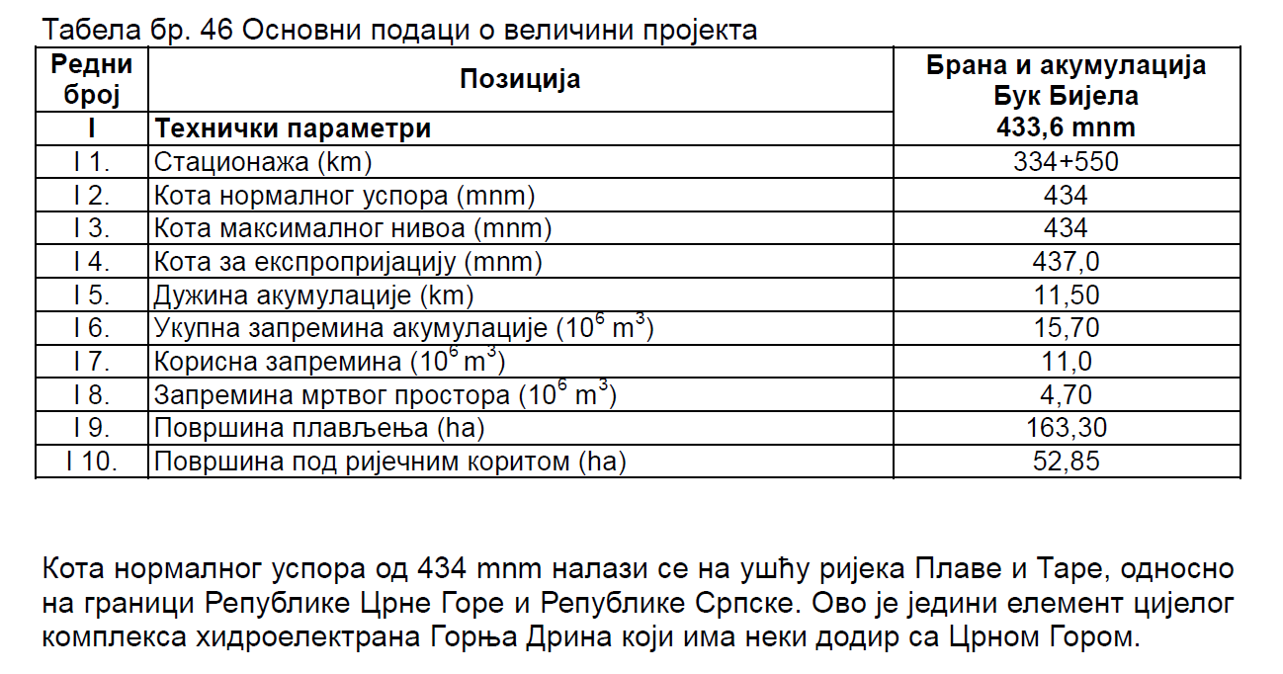
Fig 2. Capacity (EIA report HPP Buk Bijela, November 2012)

Article 2(1) and Article 4(1) of the EIA Directive, read together, indicate that projects covered by Annex I present an inherent risk of significant effects on the environment and therefore an environmental impact assessment is indispensable in those cases.
Article 7 of the EIA Directive is a fundamental provision that focuses on transboundary impact assessment. It establishes the obligations when a Contracting Party becomes aware that a project is likely to have significant environmental effects on another Contracting Party, or when a Contracting Party likely to be significantly affected requests such information. In such cases, the Contracting Party responsible for carrying out the project within its territory is required to inform the affected Contracting Party. The concerned Contracting Parties are then obligated to engage in consultations, addressing various aspects including the potential transboundary effects of the project and the proposed measures to mitigate or eliminate such effects. These consultations can be conducted through a suitable joint body established for this purpose.

Information on the cross-border working group Montenegro and Bosnia and Herzegovina
A joint expert working group consisting of representatives from Bosnia and Herzegovina, Republika Srpska, and Montenegro was established to address unresolved issues related to the implementation of the Buk Bijela hydropower plant. Their first meeting was held on 28th September 2021 in Trebinje, Bosnia and Herzegovina. During the meeting, the working group determined that conducting new geodetic surveys and hydrological measurements in the impact zone of the Buk Bijela reservoir on the border area of Montenegro was essential.
The purpose of these measurements was to calibrate and verify the hydraulic mathematical model, enabling the assessment of different hydrological scenarios affecting the Piva and Tara rivers. Additionally, it aimed to evaluate the impact of maintaining the normal water level in the "Buk Bijela" reservoir on Montenegro's territory. The initial agreement reached by the working groups was to establish the Terms of Reference for conducting topographic surveys in the border zone and hydrological measurements on defined profiles. It was further decided that the Republic of Srpska's working group would oversee the planning and organization of the topographic surveys and hydrological measurements. However, the execution of these activities would be supervised by an expert team from Montenegro.
After the harmonization of the Terms of Reference for topographic surveys and hydrological measurements between working groups from the Republic of Srpska and Montenegro, the locations in the area of Šćepan polje, where the planned measurements were envisaged to be carried out, were visited on 27 April 2022. In addition to the representatives of the working groups, the site visit was also attended by measurement operators, as well as design supervision representatives. Procedures to be implemented and a dynamic plan for the realization of measurements were defined.
Hydrological measurements were performed on 6 and 7 July 2022, while topographical surveys were performed during these two days, as well as during several other days in the month of July. After the completion of the measurement, performed in the presence of the supervision staff appointed by the working group from Montenegro Institute of Hydrometeorology and Seismology" Podgorica, the measurement operators performed appropriate processing and analysis of the measurement results and presented them in two reports:
- the Report on the Results of Geodetic Surveys, and
- the Report on the Results of Hydrological Measurements.
Following our exchange during the Energy Community Secretariat’s mission to Montenegro and to Bosnia and Herzegovina concerning the cross-border impacts and challenges of hydropower development, in particular the Buk Bijela project, and considering the different aspects of the impacts, to facilitate the discussion further the Energy Community Secretariat offered its assistance and support to streamline the cross-border dialogue.
The Energy Community Secretariat proposed to shape and expand the cross-border dialogue with representatives from the respective ministries of environment, energy and capital investments, and to establish an inter-ministerial core group.

Annex I. Decision IX/4c-V/4c
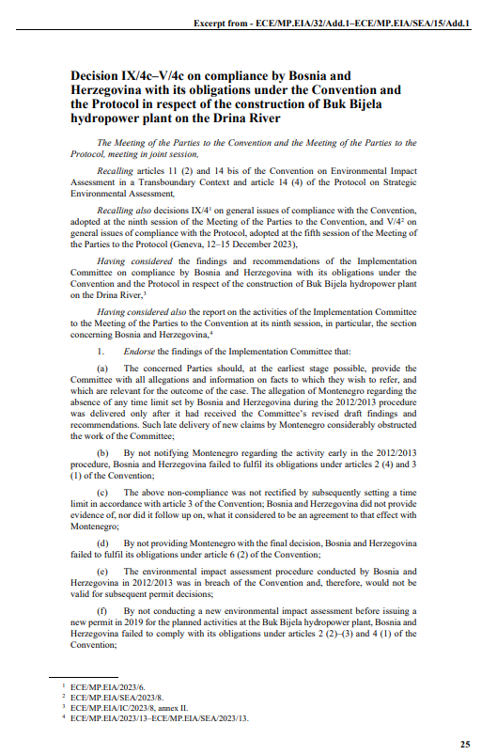

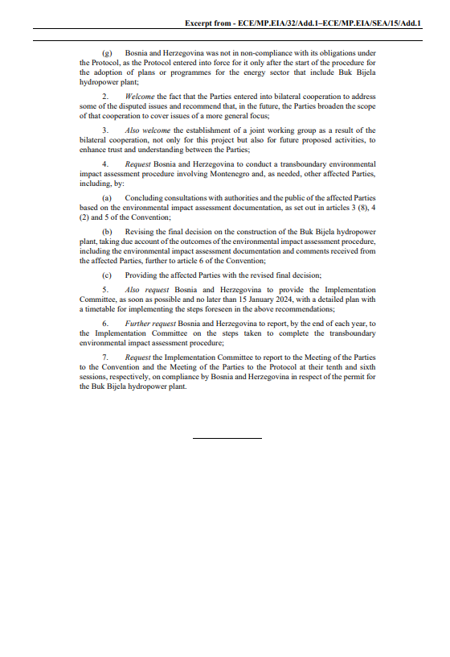

Annex II. Decision 45 COM 7B.93

